**PROJECT DESIGN PHASE – II TECHNICAL ARCHITECTURE**

|  |  |
| --- | --- |
| **Date** | 20.10.2022 |
| **Team ID** | PNT2022TMID23641 |
| **Project Name** | Analytics for Hospital’s Healthcare  Data |

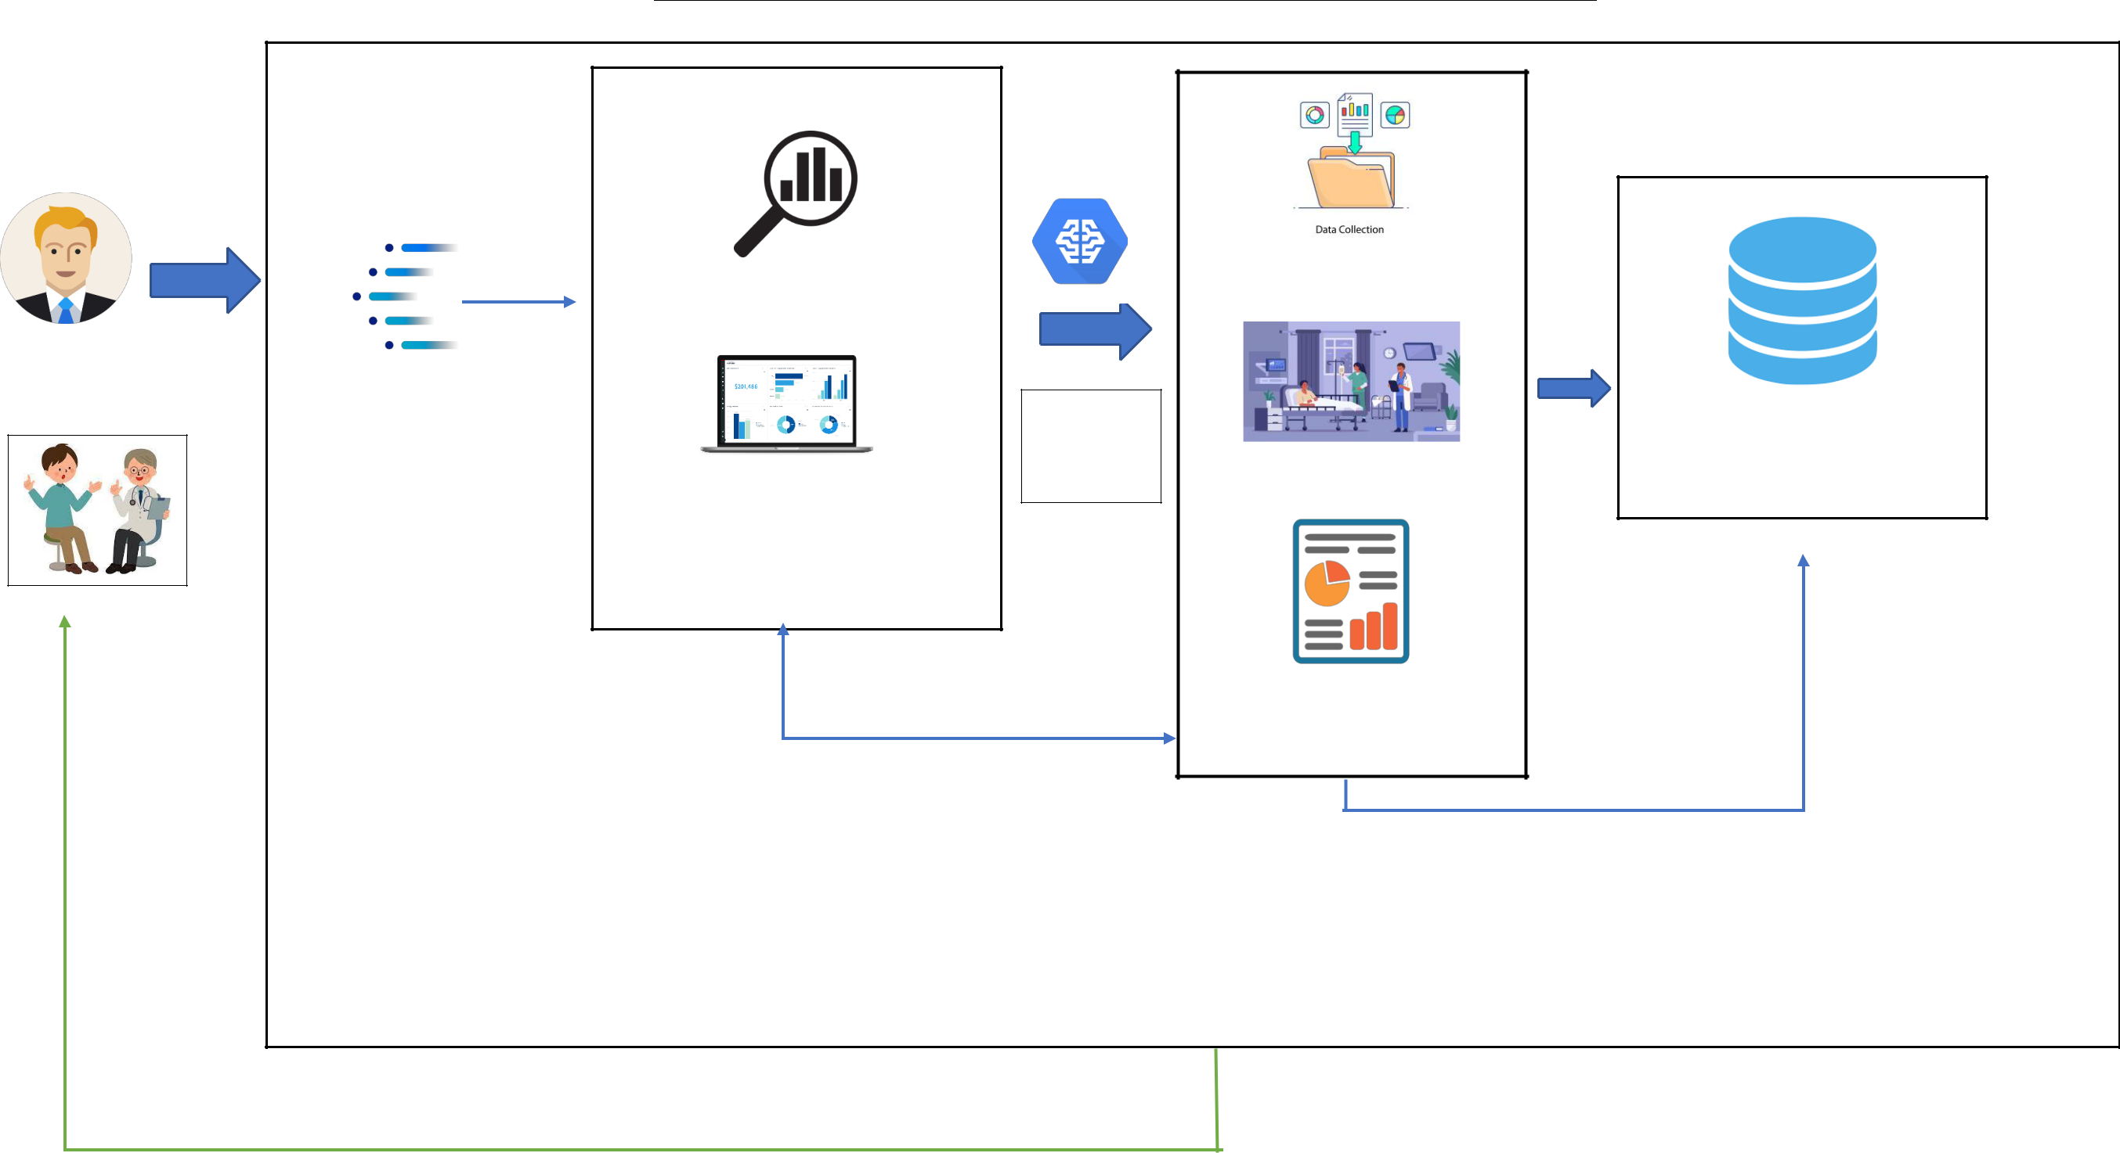

**PREDICTIVE ANALYSIS**

DATA WAREHOUSE

**DATA EXPLORATION**

Data Collection

**USER**

IBM CONGNOS

DASH BOADR

**AI aur ML**

**approach**

**Patient Length of Stay**

DATABASE

**FUTURE CONSULT**

Report generation

VISUALIZATION

STORAGE

HOSPITAL MANAGEMENT